Task 1 :-

Create these navabars :-

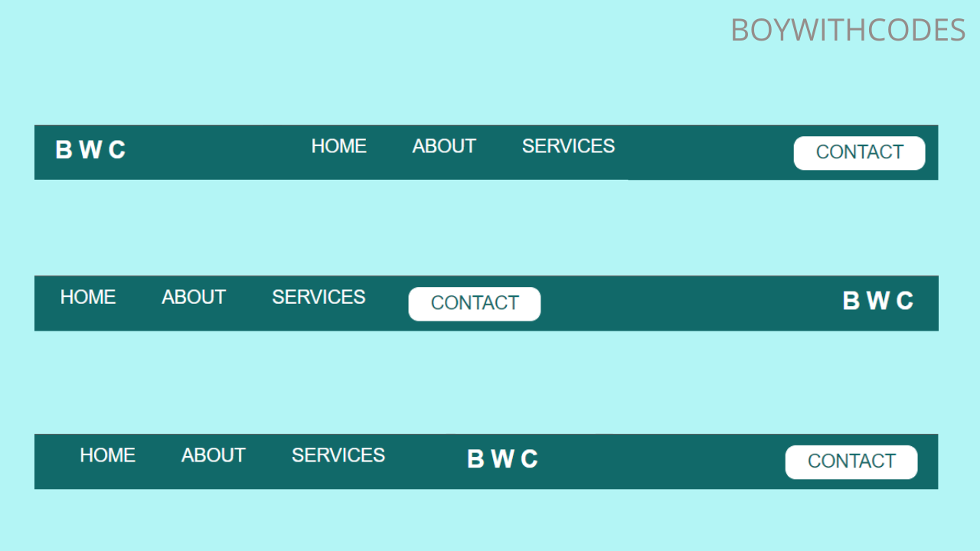

Task 2 :-

Make this html page

https://www.html.am/templates/downloads/preview.cfm?template=css-templates/fixed-width-1-green.cfm